**Reference No:** C16…..

**Damage Report Date:** .14/08/13...

**Incidents must be reported immediately.**

Damage found in Container must not to be touched until pictures have been taken to effectively demonstrate to stake holders how damage could have occurred?

In Container Container No. MOTU0321978

In Warehouse How was it damaged?

Product

NCX2000R S/N = 21HJM040A

YEP321S S/N = 21489279

*Insert* Picture:

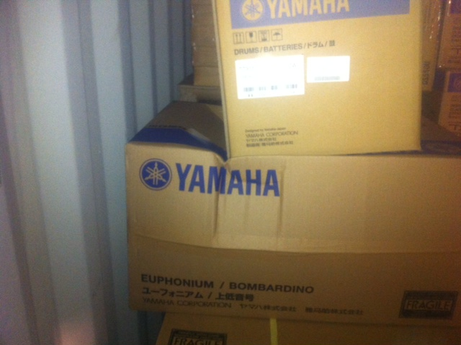

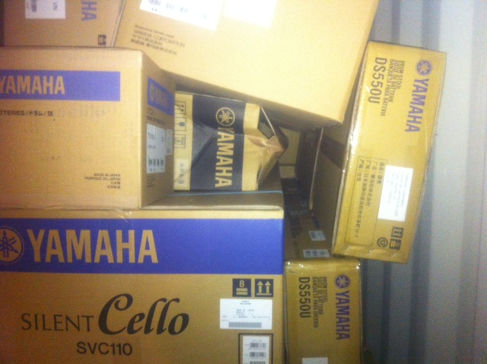

Reported by…… Frank Vastag ……………………………………….